newnumyspace tutorial

In this tutorial you will:

- Activate your area (account) on the newnumyspace web server (if you have not already done so)

- See how to add files to the web server and how to view them via a web browser

Exercise 1 – set-up your account

In this exercise you will set-up your account on the newnumyspace web server.

Activate your account on the newnumyspace web space web server

- The email should have been from an email address something like NuMyspace<webmail@newnumyspace.co.uk>. This will provide a link to a page where you can set a password. Click that and set a password

Choose a password that you can remember!
Don’t now, or ever, try to use the login option using the newnumyspace web interface. That will cause you problems. Always use FileZilla instead to manage your web space as described in exercise 2.
Note that it may take a few minutes before the password is set.
- If you have not received the email or if any of the details that should have been sent to you have not been, then tell your workshop tutor and module leader (via email) immediately
Keep your web space details
Make sure that you keep a note of your username and password. You will need the details for a lot of the rest of the module (and next year as well), so don’t lose them! Your tutors can’t access password if you forget it, so don’t.
Resetting your password
If you do ever need to reset your password, there is a ‘Forgotten your password?’ area at http://newnumyspace.co.uk (however its best not to have to). It is used as follows
- Enter your University email address Forgotten your password?’ area and click the button. Don’t try the logon option at http://newnumyspace.co.uk
- You will then get a page telling you that a password reset email has been sent to you. Open the email and follow the link provided
- In the web page that is displayed, enter and confirm the password that you want. Note that it may take a few minutes before the password is reset.
Exercise 2 - Adding and viewing files

In this exercise you will upload/publish web files (e.g. HTML, CSS files etc) to the web server.

Accessing your newnumyspace account space
- From the Start menu find the program FileZilla (Start > All Programs > Web Developer Tools > FileZilla). You should see a new window like the following

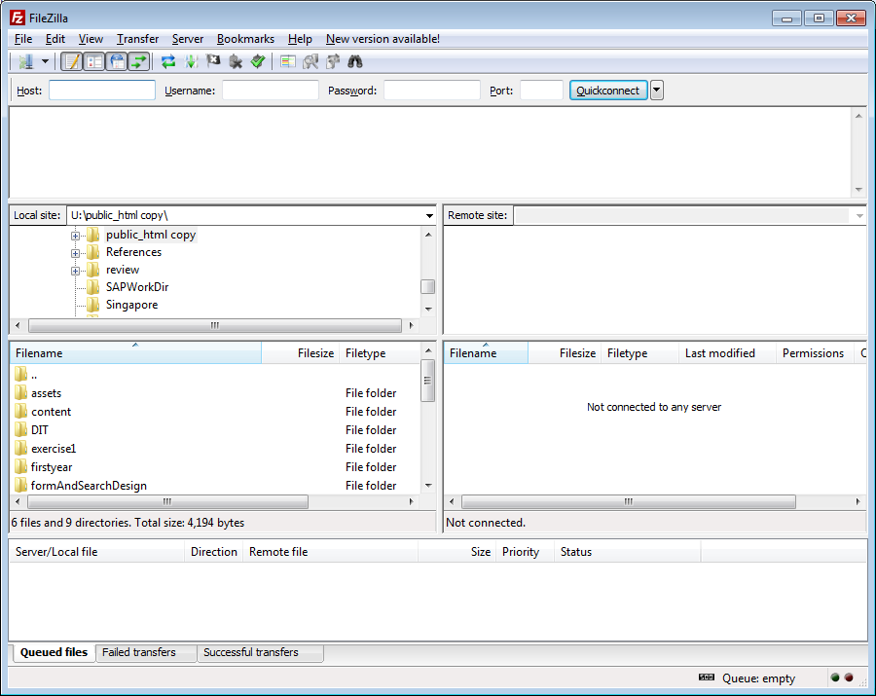

FileZilla is an FTP program that allows you to manage files (HTML, CSS etc) on a web server. With it you can add, delete and organise files.

- Now you need to enter some information that will be required to establish a link between the computer you are working on and your space on the web server.

Enter details as follows (don’t copy and paste them, type them):
- In the Host box enter newnumyspace.co.uk
- In the Username box enter your SFTP username (this should have been sent to you in an email as described in exercise 1)
- In the Password box enter your SFTP password that you have recently set
- In the Port box enter 22

- Click QuickConnect

You should now have made a connection between the computer you are on and your web space area on the newnumyspace web server. The window should change to look something like the following (in this screen shot there are more folders etc than you will have at the moment):

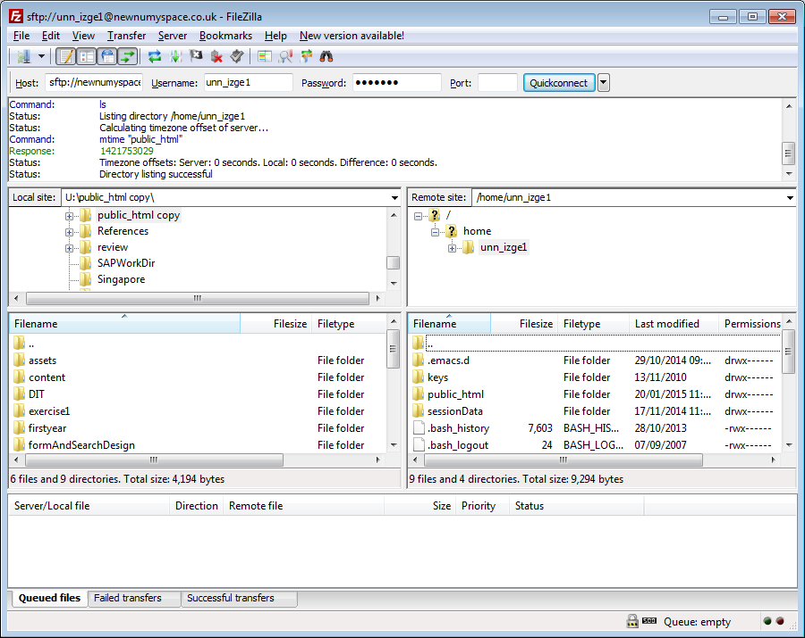

Left hand side – on the left you should see a Local site area that shows the drives, folders etc on the computer that you are working on. You can click to expand a drive (e.g. U:) by clicking on the relevant cross symbol. This should display any folders / files that you have on the drive. You can open folder etc as you wish.

Right hand side – on the right you should see a Remote site area that shows the folder structure etc for your account on the newnumyspace web server. This includes any folders in your account area.

You should have a folder called public_html (if this does not exist you will need to create it by right clicking, selecting Create Directory, and naming the folder public_html).

Uploading files to your web server space
- In the Local site area navigate to and select one of the web files that you created as part of a previous workshop for this module (e.g. first.html)

- In the Remote site area on the right side of the screen double click the public_html folder to open it

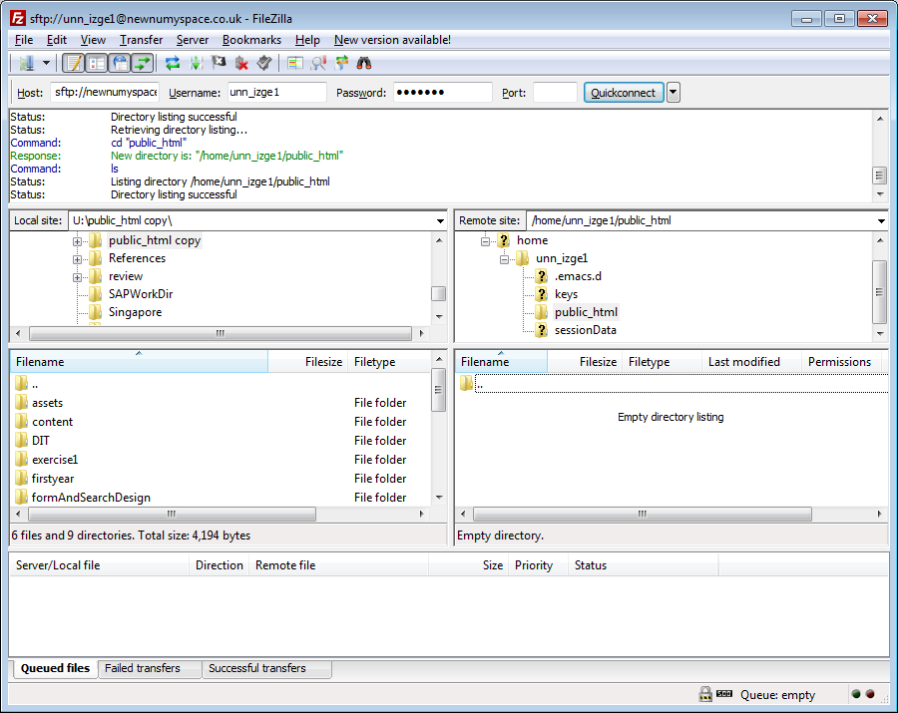

- Now drag the file that you have selected in the Local site area and drop it into the public_html folder in the Remote site area. A copy of the of the file should now have been placed into the public_html folder of your space on the web server, e.g.

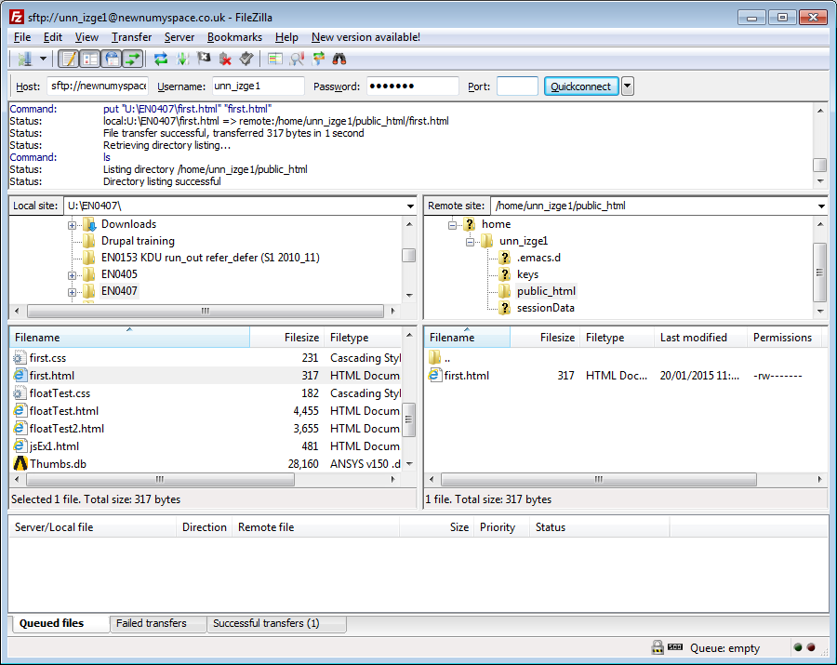
You could now add copies of any further files (e.g. first.css) that you want to your web space in the same way.

NOTES:

You can also create sub-folders within the public_html folder if you want to help to organise your files.

You can place copies of whole folders onto the web server at once if you wish by dragging and dropping them from Local site area to the Remote site area (in the required location)

You can also download files (or whole folders if you wish) from the web server to your local computer if you wish by dragging and dropping from the Remote site area to the Local site area.

Viewing your uploaded files

- Open a new browser window

- Enter the web site address that was sent to you in the email referred to earlier (e.g. http://unn-YOURSFTPUSERID.newnumyspace.co.uk/), add onto the end of it the name of the web file that you copied into public_html earlier. The web site address should now look something like http://unn-izge1.newnumyspace.co.uk/first.html), and press Enter. Your web file should now be displayed in the web browser window

YOURSFTPUSERID should obviously be replaced with the SFTP username sent to you in the email referred to earlier.

Downloading FileZilla for use outside of University

If you want a copy of FileZilla to use away from University you can download a copy of FileZilla from the following location:

http://filezilla-project.org/

You need to choose Download FileZilla Client all platforms and then pick the Windows version.

